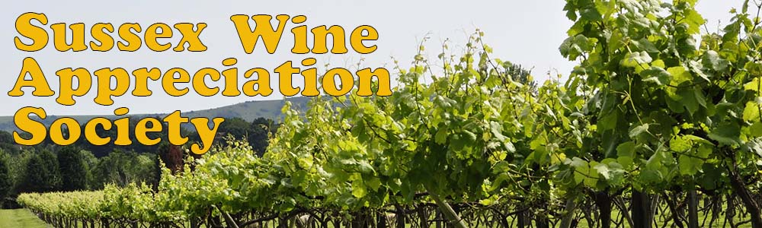
SWAS September Spanish Picnic 2020
Dedicated to the memory of Adrienne and Janis

# | Wine | Region | Vintage | Alc by Vol | Grapes | Guess the Price?
1 | Cava Conde de Haro | Rioja | 2017 | 12% | Maccabeu | £13.99
2 | The Society’s White Rioja | Rioja | 2018 | 12.5% | 90% Viura, 10% Malvesia | £ 8.95
3 | Pepe Mendoza White Blend | Alicante | 2018 | 13% | Moscatel/Alejandria/Macabeo | £11.95
4 | De Morgenzon Reserve Chenin Blanc (*) | Stellenbosch SA | 2016 | 14% | Chenin Blanc | £25.00
5 | The Society’s Rioja Crianza | Rioja | 2016 | 14% | Tempranillo | £ 8.50
6 | Pepe Mendoza Red Blend | Alicante | 2017 | 14% | Monastrell/Syrah/Alicante Bouschet | £11.95
7 | The Society’s Exhibition Duero | Ribero del Duero | 2016 | 14% | Tempranillo (Tinto del Pais) | £14.95
8 | Silice Red | Ribeira Sacra | 2018 | 12.5% | Mencia | £19.00
9 | Casa Ardanza Rioja | Rioja Alta | 2010 | 13.5% | Tempranillo | £23.50
10 | Romate Amontillado Olvidado | Amontillado | Very Old, +25 years…! | 20% | Palomino | £17.00 (375ml)
(*) From the SWAS Cellar
Raffle Wines:
- The Society’s Greek White 2019
- A Primitivo from Puglia

